***Name : Siddhi Hagawane***

***Batch : B3***

***Class : BTech CSE 2020BTECS00049***

***Subject : High Performance Computing Lab***

Assignment – 12 : Analysis of MPI Programs

1. Execute the MPI program (Program A) with a fixed size broadcast. Plot the performance of the broadcast with varying numbers of processes (with constant message size). Explain the performance observed.





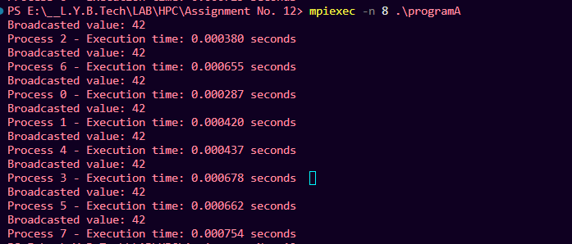

The execution times vary among processes, which is expected in a distributed environment. The execution time depends on factors like network

communication and system load.

Processes 0, 2, and 4 have relatively shorter execution times, while processes 3,

5, 6, and 7 have slightly longer execution times.

1. Repeat problem 2 above with varying message sizes for reduction (Program B). Explain the observed performance of the reduction operation.





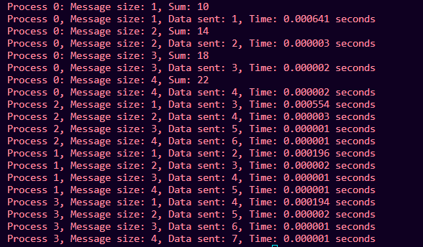

This MPI program performs parallel reductions across multiple processes. It initializes MPI, computes and prints the sum of values from different processes, and measures the time taken for each reduction operation with increasing message sizes. The output shows consistent sums and provides insights into the efficiency of MPI communication and synchronization. Each process calculates its data independently, and the program demonstrates parallel execution, with each process contributing to the reduction operation. The time measurements

are very short, indicating low MPI overhead. This code showcases the utility of MPI for parallel computing and distributed data processing.

**GitHub Link:**

<https://github.com/Siddhish16/HPC-Assignments>

